***Lab 8***

Name: Sarthak Raj

Roll no: 22it3042

**Question 1**

Index.jsx

import React from 'react';

import ReactDOM from 'react-dom';

import App from './App';

ReactDOM.render(<App />, document.getElementById('root'));

App.jsx

import React, { useState } from 'react';

const CurrencyConverter = () => {

const [amount, setAmount] = useState('');

const [fromCurrency, setFromCurrency] = useState('USD');

const [toCurrency, setToCurrency] = useState('EUR');

const [convertedAmount, setConvertedAmount] = useState(null);

const exchangeRates = {

USD: {

EUR: 0.84,

INR: 74.19

},

EUR: {

USD: 1.19,

INR: 83.32

},

INR: {

USD: 0.013,

EUR: 0.012

}

};

const handleAmountChange = (*e*) => {

setAmount(e.target.value);

};

const handleFromCurrencyChange = (*e*) => {

setFromCurrency(e.target.value);

};

const handleToCurrencyChange = (*e*) => {

setToCurrency(e.target.value);

};

const handleConvert = () => {

const rate = exchangeRates[fromCurrency][toCurrency];

const converted = parseFloat(amount) * rate;

setConvertedAmount(converted.toFixed(2));

};

return (

<div>

<h2>Currency Converter</h2>

<div>

<label *htmlFor*="amount">Amount:</label>

<input *type*="number" *id*="amount" *value*={amount} *onChange*={handleAmountChange} />

</div>

<div>

<label *htmlFor*="fromCurrency">From:</label>

<select *id*="fromCurrency" *value*={fromCurrency} *onChange*={handleFromCurrencyChange}>

<option *value*="USD">USD</option>

<option *value*="EUR">EUR</option>

<option *value*="INR">INR</option>

</select>

</div>

<div>

<label *htmlFor*="toCurrency">To:</label>

<select *id*="toCurrency" *value*={toCurrency} *onChange*={handleToCurrencyChange}>

<option *value*="USD">USD</option>

<option *value*="EUR">EUR</option>

<option *value*="INR">INR</option>

</select>

</div>

<button *onClick*={handleConvert}>Convert</button>

{convertedAmount && (

<p>

Converted Amount: {convertedAmount} {toCurrency}

</p>

)}

</div>

);

};

export default CurrencyConverter;

**Output**

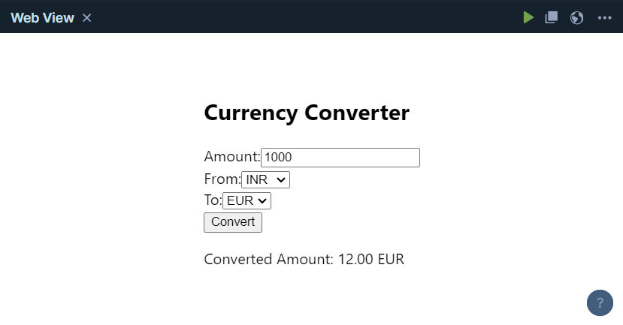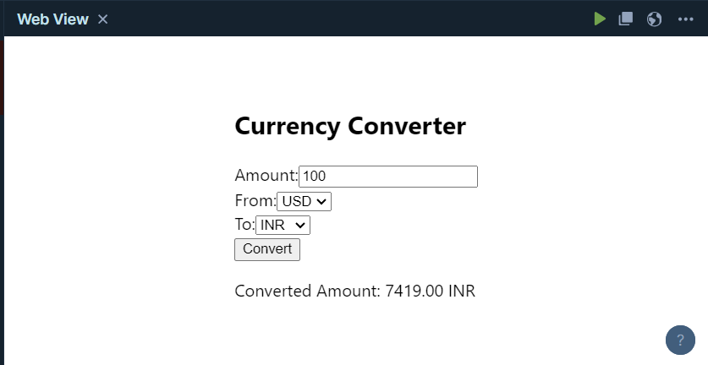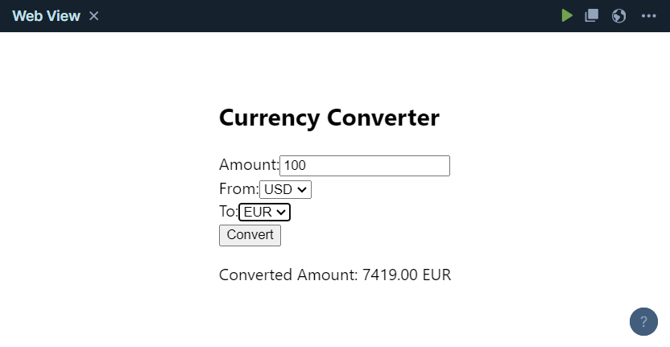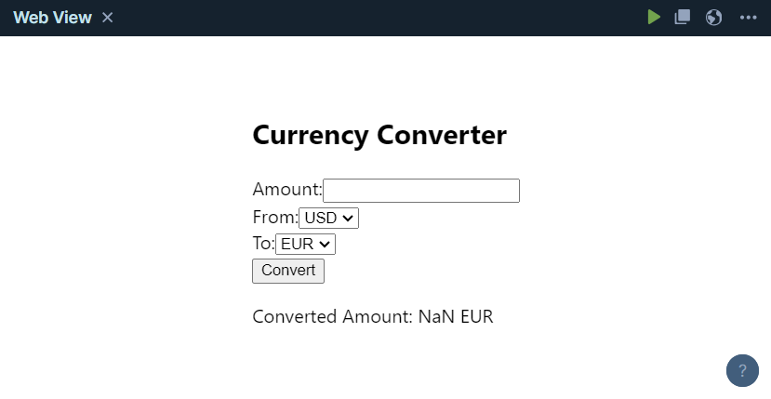

**Question 2**

index.jsx

import React from 'react';

import ReactDOM from 'react-dom';

import App from './App';

ReactDOM.render(<App />, document.getElementById('root'));

App.jsx

import React, { useState, useEffect } from 'react';

const Stopwatch = () => {

const [time, setTime] = useState(0);

const [isRunning, setIsRunning] = useState(false);

useEffect(() => {

let intervalId;

if (isRunning) {

intervalId = setInterval(() => {

setTime((*prevTime*) => prevTime + 1);

}, 1000);

} else {

clearInterval(intervalId);

}

return () => clearInterval(intervalId);

}, [isRunning]);

const startTimer = () => {

setIsRunning(true);

};

const pauseTimer = () => {

setIsRunning(false);

};

const resetTimer = () => {

setTime(0);

setIsRunning(false);

};

const formatTime = (*time*) => {

const minutes = Math.floor(time / 60);

const seconds = time % 60;

return `${minutes < 10 ? '0' : ''}${minutes}:${seconds < 10 ? '0' : ''}${seconds}`;

};

return (

<div *className*="stopwatch-container"> {*/* Add a class for styling */*}

<h2 *className*="stopwatch-header">Stopwatch</h2> {*/* Add a class for styling */*}

<div *className*="stopwatch-content"> {*/* Add a class for styling */*}

<p *className*="stopwatch-time">{formatTime(time)}</p> {*/* Add a class for styling */*}

<div *className*="button-group"> {*/* Add a class for styling */*}

<button *className*="start-button" *onClick*={startTimer} *disabled*={isRunning}>Start</button> {*/* Add classes for styling */*}

<button *className*="pause-button" *onClick*={pauseTimer} *disabled*={!isRunning}>Pause</button> {*/* Add classes for styling */*}

<button *className*="reset-button" *onClick*={resetTimer}>Reset</button> {*/* Add classes for styling */*}

</div>

</div>

</div>

);

};

export default Stopwatch;

CSS File

.stopwatch-container {

margin: 20px;

padding: 20px;

border: 1px solid #ccc;

border-radius: 5px;

}

.stopwatch-header {

font-size: 24px;

margin-bottom: 10px;

}

.stopwatch-content {

display: flex;

align-items: center;

}

.stopwatch-time {

font-size: 36px;

margin-right: 20px;

}

.button-group button {

font-size: 18px;

padding: 10px 20px;

margin-right: 10px;

border: none;

border-radius: 5px;

cursor: pointer;

}

.start-button {

background-color: #5cb85c;

color: #fff;

}

.pause-button {

background-color: #d9534f;

color: #fff;

}

.reset-button {

background-color: #f0ad4e;

color: #fff;

}

**Output**

